###### Tel: 07943 688760

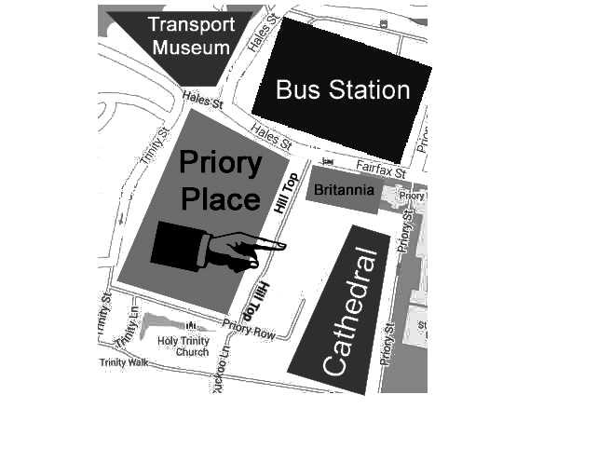

Bardsley Youth Project



Our centre is at Bardsley House on Hill Top - the cobbled lane that runs down the side of the Britannia Hotel opposite the Bus Station.

# Bardsley House

# Hill Top

# Coventry

# CV1 5EP

**Website:** [**www.bardsleyyouth.org**](http://www.bardsleyyouth.org)

**E-mail:** [**pat@bardsleyyouth.org**](mailto:pat@bardsleyyouth.org)

**simon@bardsleyyouth.org**

Registered Charity Number: 1152836

Information for Young People

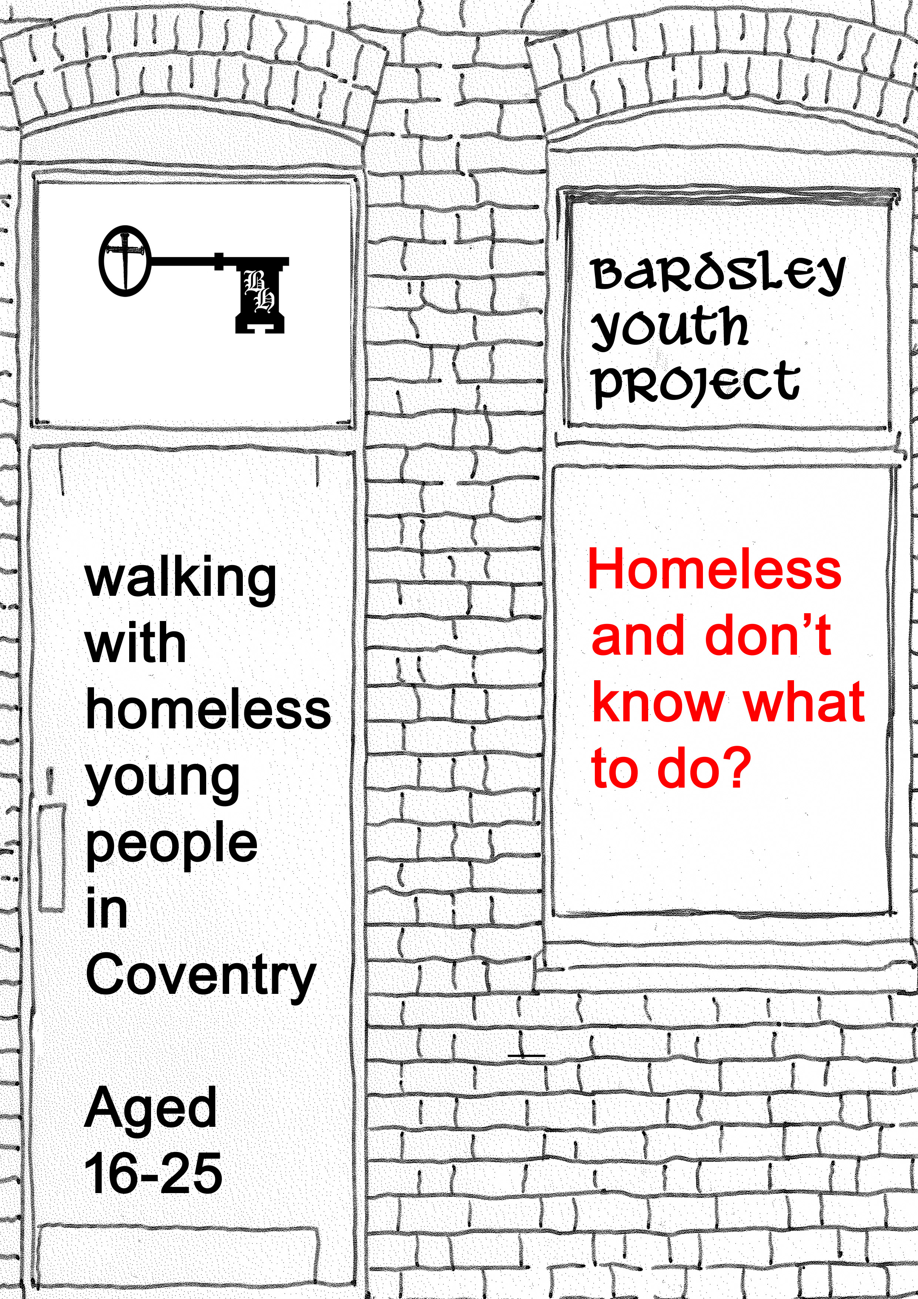

**‘I really am not happy at home so I am just going to move out and get a flat with my mate.’**

**Sounds easy doesn’t it?**

The reality is that unless you are at risk it really is much better to stay at home and try and leave in a planned way, getting your accommodation set up before you leave home. The process of finding accommodation and sorting out the finances to keep it can take many weeks and being homeless in the meantime will be very hard. We can help you to plan to leave.

If you have to leave home in a hurry, ask family and friends if you can stay with them until something is sorted out. It may be worth going back home and talking things through, something we can also help you with.

If you have nowhere to stay tonight, phone the council on

024 7683 4025 or go to the council’s Customer Service Centre which is in The Precinct, just off Broadgate behind Starbucks.

**Get in touch with us for help – contact details are on the back page.**

When you leave, try and take as many of the following items as possible – this will help while you are homeless and also get the process of finding somewhere to live started quickly.

Documents – passport, birth certificate, National Insurance number, driving licence, photo ID, benefits letters, bank cards.

Stuff – medication, address book, change of clothes, toiletries.



**We will walk with you as you move forward, helping you find accommodation and keep it.**

**We can help support you….**

* **Advice about housing options and benefits**
* **Help with form filling and applications**
* **Internet and phone access**
* **Referral to specialist agencies if needed**
* **Mediation to help you return home if appropriate**
* **Accompanying you to appointments**
* **Liaising with and referrals to other agencies to find solutions**
* **Support for you in accommodation to help you maintain your tenancy – money management, life skills and emotional support**

We also offer practical help….

* **Food bank tailored to cooking with only a kettle, as well as basic toiletries**
* **Furniture bank of donated beds, sofas etc to help set up your first accommodation with basic needs**
* **Household goods – donated crockery, utensils etc**
* **Clothing bank**
* **Laundry facilities**
* **Shower room**

All of our services are free. We will work alongside you,

working in your best interests and will not contact people or organisations you don’t want us to.

